**Travel Guider**

**Business Requirement**

One travel company in Sri Lanka wants to keep their tourist visiting exciting. They are planning to arrange a wildlife forest trip only with the GPRS system. There will be no tourist guide except only a mobile. The route of the tourist wildlife walk will be stored online by the tourist company with the map for the walk. The tourist can be able to choose which wildlife walk path he wants to walk. Once the tourist chooses the path, the tourist will be able to walk in the wildlife park using the Google map system to walk from one map point to another map point. During the time of the walk, they will take pictures and record video in and store them with the geolocation in the local database. The mobile app will automatically send the images and videos to a server to keep the tourist company alert about the live location of the Tourists. Any tourist in danger will be able to make a video call to the tourist company. The tourist company will track every moment the tourist’s position by live location. You have to design the app using flutter and sql lite and other framework libraries by using audio / video / google map system functions.

**Software requirement specification**

We will develop an application that will provide a login page for users, the system will register the user from a registration page. The user will provide an address and mobile number on the registration form. All the forms will have validations. There will be a safe routing system so no one can enter the dashboard without login.  There will be a user interface for taking the

Start and end point of an appointment visit. The user will be able to gothe **location** from the application to the database. The admin will save the appointment visit and can see it from a list view of an application. The user can click on the list view to see the details of the appointment visit and can start the travel by clicking the **go** button. Go button click will open the google map application from the starting point to the destination. During the navigation user can **capture image and videos**. If user face any danger user can make **video call** as well as **send notification to the travel company with location and image**. Image and videos will be saved in **local database**.

**System Architecture Diagram**

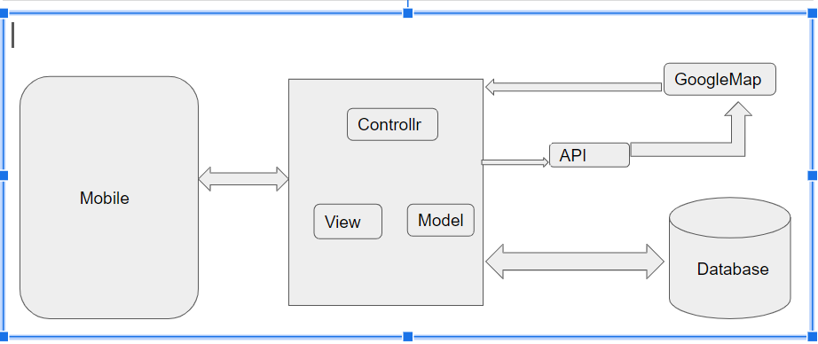

**Database Design**

|  |
| --- |
| **User Table** |
|  |
| User ID int (PK) |
| Name String |
| Email String |
| Password String |

|  |
| --- |
| **List Places** |
| Place id int(pk) |
| Latitude real |
| Longitude real |
| User ID int (fk) |

|  |
| --- |
| **Geolocation** |
| Place id int (pk) |
| Pic Id int |
| Video ID int |
| Latitude real |
| Longitude real |
| User ID int (fk) |



|  |
| --- |
| **Information Table** |
| Image id int (pk) |
| Latitude real |
| Longitude real |
| Image blob |
| Video blob |
| User ID int (fk) |



**UI Design**

Registration & Login

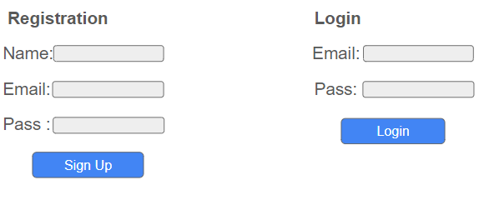

List of Places

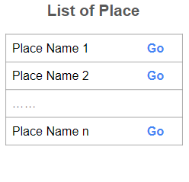

Navigation

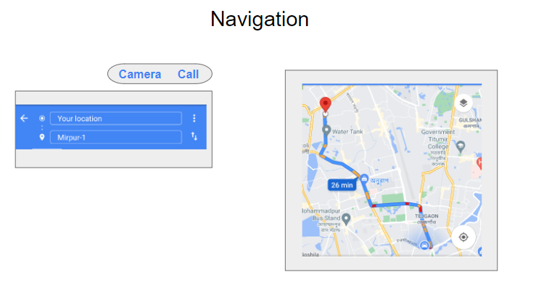

Capture Image & Videos

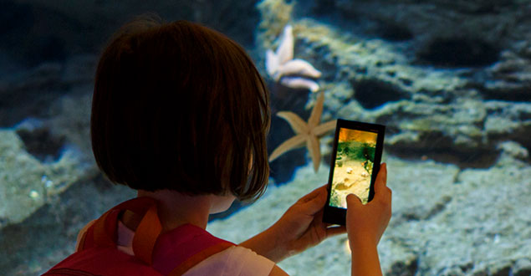

Video Call

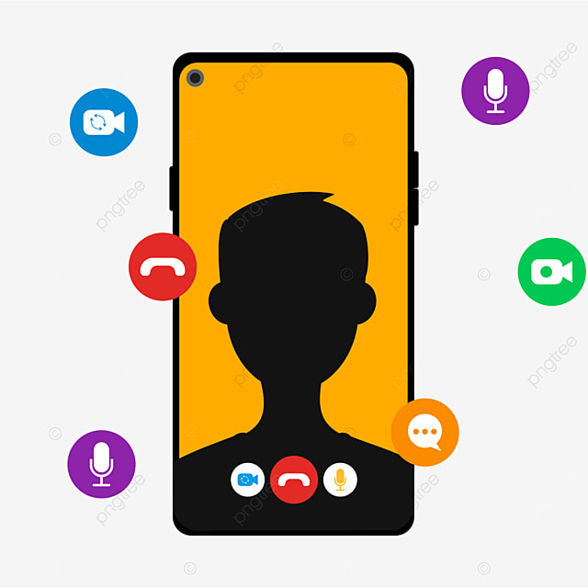

### **Software Development**

#### **Tools:**

Flutter

Dart

SQFLite